

**Recommendations**

**1. Functionality-wise (as an e-commerce site)**

- Customers still have to click over the menu to have an idea of what we are selling

- A picture of groceries is in the background but the watermark effect still makes it vague

- Maybe it would be better to have a picture of product samples or the categories of the products that we sell to give the customers an idea of what we are selling at first glance.

Site references:

[Market Cebu](http://marketcebu.com/)



[Fresh Direct](https://www.freshdirect.com/index.jsp)

[mySupermarket](http://www.mysupermarket.co.uk/)

**2. Product Bundles**

- Other than the existing categories, we could add other “seasonal” product bundles such as:

Christmas essentials (Products that are usually in-demand during the holidays)

Sunday specials (Ingredients for home-cooked meals)

Pinakbet essentials (Basic ingredients to make a pinakbet)

Adobo especial (Basic ingredients to make adobo)

Some examples:

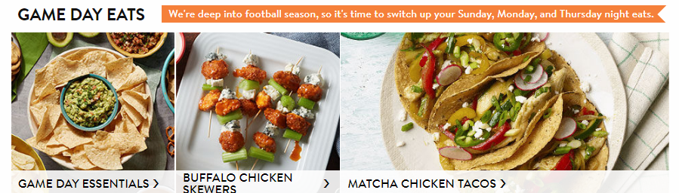

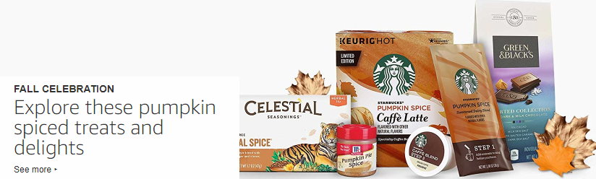

**3. Product Labels**

- The word **SALE** is always catchy as well as discounts and SAVE

- We could add these to products that are “in-season”

Some examples:

[Amazon Grocery](https://www.amazon.com/grocery-breakfast-foods-snacks-organic/b/ref=sd_allcatpop_gro/103-3690168-6750236?ie=UTF8&node=16310101&tag=aboutcom02lifewire-20)

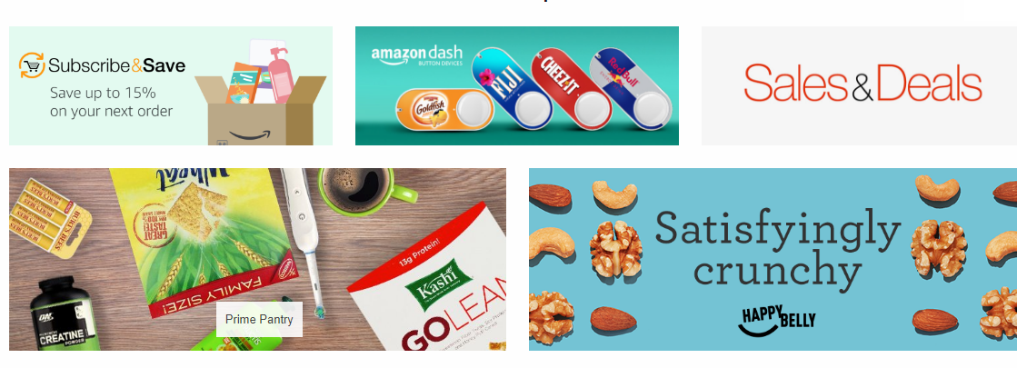

[Fresh Direct](https://www.freshdirect.com/index.jsp)

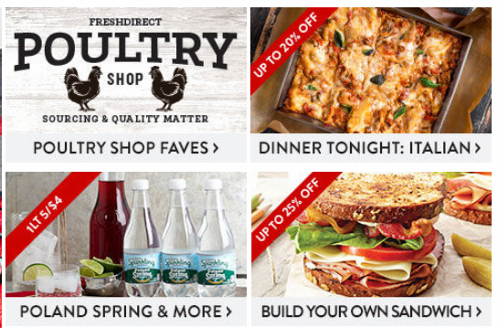

**4. Featured Products/Best-selling Products/Product Brands**

- We could also feature our best-sellers or products brands that we offer

Site references:

[Cebu Grocer](http://cebugrocer.com/)

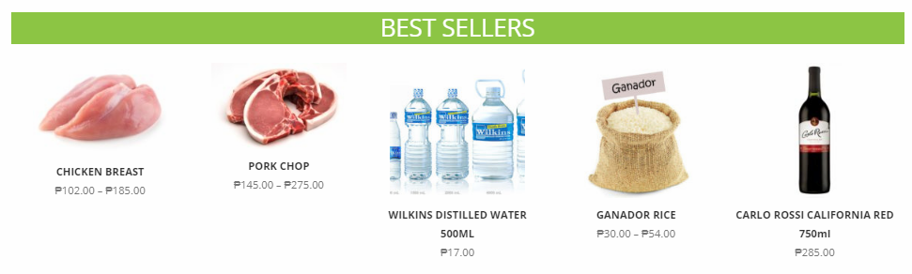

[Cebu Grocery](http://www.cebugrocery.com/)

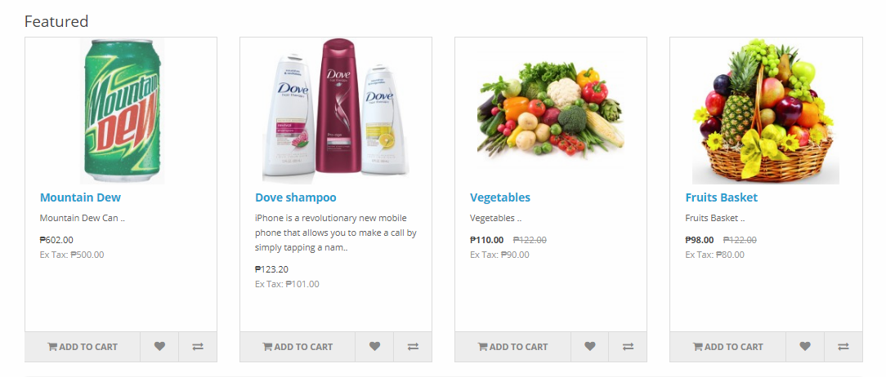

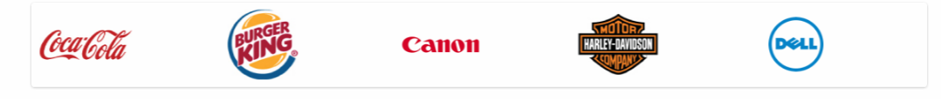

[MyTindahan](https://mytindahan.net/)